

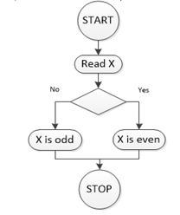

/\* Algorithm for converting a value in seconds to hour, minutes and seconds \*/

1. START

2. PRINT “ENTER TIME IN SECONDS”

3. INPUT TimeInSeconds

4. Mins = TimeInSeconds/60 //(Integer Division value = 5024 secs)

5. RemainignSeconds = TimeInSeconds - Mins\*60 // 83 mins ; 44sec

6. H = Mins/60 //(Integer Division 83/60 = 1)

7. Mins = Mins - H\*60 // 23 mins

8. PRINT TimeInSeconds, “SECONDS IS EQUIVALENT TO”

10. PRINT H , “HOURS”

11. PRINT Mins , “MINUTES”

12. PRINT “ AND”

13. PRINT RemainingSeconds , “ SECONDS”

14. STOP

// Comment – Demo C++ program